**Corporate Finance**

Project Report on Aviation Industry

Milan Kumar Sahu

# INTRODUCTION

This report delves into the Aviation Industry, with a specific emphasis on prominent entities including Indigo, Spicejet, Jet Airways, GlobalVect, BEL, and HAL. The central aim of our analysis is to ascertain the Weighted Average Cost of Capital (WACC) and elucidate the most effective capital structure for each of these corporations. The operations of the air transport industry and its considerable economic influence necessitate a closer examination. Various external elements, including unpredictable fuel costs, intricate legal structures, and heightened vulnerability to economic shifts, pose inherent risks to this sector. The imperative to undertake thorough financial analyses of the aviation industry is underscored by the recent global disruption stemming from the COVID-19 pandemic last week.

## Global Aviation Market

Over the projected timeframe spanning from 2022 to 2027, the global aviation market is anticipated to exhibit a compound annual growth rate of 25.5%. The continued expansion of the global air transport sector in the coming years is expected, driven by rising household incomes, the swift growth of middle-class populations, and an escalating demand for travel. Furthermore, the relatively stable projection of jet fuel prices throughout the forecast period is poised to enable aviation to implement surcharges, thereby augmenting their revenue from both passenger and freight transportation.

Air freight stands as a crucial component facilitating international trade in manufactured goods, particularly components, constituting a significant proportion of cross-border trade. This year, the value of international trade conducted via air is forecasted to reach $7.5 billion, reflecting a 15% increase from 2019, with an additional anticipated growth of 7.2% in 2022. The upsurge in tourism expenditure on air transport further propels growth, as evidenced by the $354 billion total spent by passengers traveling by air in 2021.

Market expansion is driven by various factors, including heightened private sector involvement and investments, increased business engagement leading to a rising demand for non-scheduled aircraft, greater utilization of construction fees by terminal builders and operators, amplified exports and imports, and an upswing in freight traffic.

Over the forecast period, aviation fuel availability and expenditure continue to play a pivotal role as primary economic factors influencing air traffic for three decades. Addressing emissions from aircraft poses a challenge due to a lack of aerodrome climate governance at both national and regional levels, emerging as another issue facing the market in the coming years.

## INDIAN MARKET

## In March 2023, domestic flights in India served a total of 13 million passengers. As per the Ministry of Civil Aviation, the country is projected to accommodate over 140 million passengers starting from the fiscal year 2024. Over the next two decades, India is tasked with managing an annual passenger volume exceeding 1.3 billion. Currently boasting 148 airports, India holds the position of the third-largest domestic market globally in terms of seat capacity.

## IndiGo, leading the domestic market in India, commands a substantial market share of 56.8%, followed by Vistara with 8.9% and Air India with 8.8% as of March 2023.

## With the Indian government's investments in airport infrastructure, India is increasingly regarded as the world's most intriguing aviation market. According to the International Air Transport Association (IATA), representing over 300 aviation, the anticipated growth in post-pandemic travel is expected to bolster aviation revenues in 2024. Following a challenging period, the aviation industry is set to return to profitability in 2023, projecting a net profit of $23.3 billion with a margin of 2.6%.

## ESTIMATION OF BETA

The beta of an industry is a measure of its volatility in relation to the overall market.

As you can see, all companies have a re-levered beta higher than their Unlevered Beta. This indicates that all companies take on more risk due to their leverage. Investors should know this risk before investing in any of these companies.

Among the Companies chosen, Indigo has the highest re-levered beta of 1.04. Generally, higher beta stocks are associated with higher risk but also the potential for higher returns. Indigo, with a beta of 1.04, is likely to be more sensitive to market dynamics, making it a riskier investment compared to the other companies with lower beta.

The Industry Beta is 0.58. This suggests that the aviation industry as a whole is slightly less risky than the overall Indian market.

### **COST OF EQUITY**

We have calculated the cost of equity based on the formula, E(Ri) = Rf + βi * [E(Rm) – Rf]

Where - E(Ri) = Expected return on asset i

Rf = Risk-free rate of return

βi = Beta of asset i

E(Rm) = Expected market return

Indigo is at the higher end of the spectrum, suggesting that investors may perceive it as riskier or expect higher returns compared to the others. This higher Re value aligns with a higher cost of equity calculated earlier.

We have taken the value of the Market Risk Premium and Risk-free rate as per the expert’s consideration (Aswath Damodaran).

### **COST OF DEBT**

We have calculated the cost of debt based on the formula -

**Cost of Debt=Annual Interest Expense / Total Debt×(1−T)**

Where, T=Tax Rate

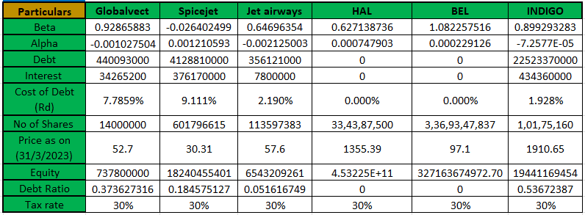

## WACC CALCULATION

We have calculated the WACC based on the weight of debt and equity and also the rate of debt and equity, and the tax rate.

The formula of WACC is -

**WACC = (E/V x Re) + ((D/V x Rd) x (1 – T))**

Where,

E = Market value of the firm’s equity

D = Market value of the firm’s debt

V = Total value of capital (equity plus debt)

E/V = Percentage of capital that is equity

D/V = Percentage of capital that is debt

Re = Cost of equity

Rd = Cost of debt

T = Tax rate

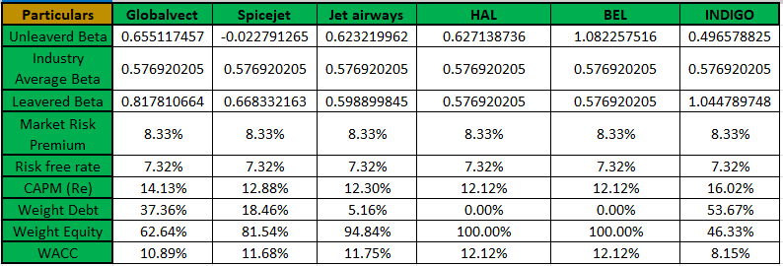

## WACC ANALYSIS

## A reduced Weighted Average Cost of Capital (WACC) signals a decline in overall financing expenses, representing a favourable scenario for the company with an optimal capital structure. This implies that the company can provide returns to investors at a lower cost. Companies boasting lower WACC may encounter less difficulty in pursuing new projects or investments due to the lower cost of capital.

## Conversely, an escalation in WACC could pose challenges for a company in securing cost-effective financing options, potentially impacting its ability to execute profitable projects.

## Based on our analysis, it is evident that INDIGO possesses the lowest WACC, indicative of an optimal capital structure. Following closely are GLOBALVECT, SPICEJET, JET AIRWAYS, and BEL and HAL, occupying the same advantageous position with the lowest WACC. The repeated WACC values for BEL and HAL suggest potential similarities in their risk profiles or financial structures.

## DIVIDEND STRUCTURE ANALYSIS

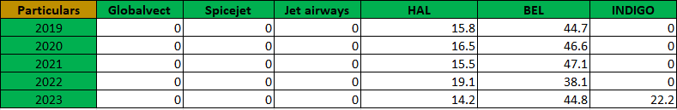

The dividend payout ratio (DPR) is a financial ratio that measures the proportion of a company's net profits that is distributed to shareholders as dividends.

While SpiceJet, Jet Airways, and Global Vectra prioritize reinvesting profits for future growth, HAL and BEL consistently reward shareholders with regular dividends. This reflects contrasting priorities: reinvestment for rapid expansion versus consistent shareholder returns. IndiGo, on the other hand, strikes a balance. It maintains a steady stream of dividends through a moderate payout ratio while reinvesting resources to fuel its growth strategy. This approach appeals to both income-seeking investors and those seeking capital appreciation.

## CAPITAL STRUCTURE ANALYSIS

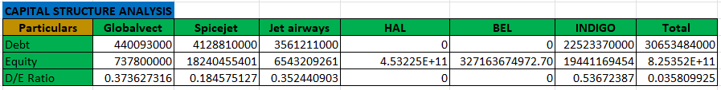

## The companies under consideration display significant diversity in their capital structures, with debt ratios spanning from 0 to 0.5367. The average debt ratio of 0.0333 indicates an overall inclination toward equity financing. However, Indigo stands out as it relies more heavily on debt for operational funding.

## This variation in debt ratios is likely attributed to differing business strategies and levels of financial risk tolerance among these companies. Those with lower debt ratios may adopt a conservative approach, opting for equity financing to prioritize financial stability.

## Conversely, companies with higher-than-average debt ratios may strategically leverage debt to finance capital-intensive projects or navigate cyclical market periods.

## A debt ratio of 0 suggests an absence of debt in the capital structure, possibly indicating a conservative financing approach or a reliance on equity.

## WORKING CAPITAL

Since the aviation industry is a service-based industry, we calculate the Working Capital by the following formula :

### **Working Capital = Current Assets - Current Liabilities**

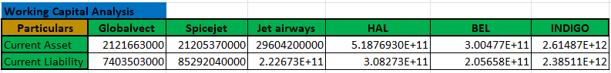



The selected companies exhibit a broad spectrum of working capital positions. A high working capital position signifies that a company possesses more current assets than current liabilities. While this indicates ample liquidity for meeting short-term obligations, it may also imply less efficient asset utilization. Conversely, a low working capital position suggests that a company holds more current liabilities than current assets, posing a risk in meeting short-term obligations. However, it may also signify efficient asset utilization.

**Specifically:**

**Globalvect:** The company boasts a robust working capital position, indicating substantial liquidity to effortlessly fulfil short-term obligations. However, there's a potential concern regarding efficient asset utilization that investors should vigilantly monitor.

**INDIGO and SpiceJet**: Both companies demonstrate healthy working capital positions, ensuring sufficient liquidity to meet short-term obligations and make assets readily available. Investors can find comfort in the favourable working capital situations of these companies.

**HAL:** HAL maintains a moderate working capital position, signifying adequate liquidity for short-term obligations but suggesting less efficient asset usage compared to INDIGO and SpiceJet. Investors are advised to closely track HAL's working capital trends to ensure improvement over time.

**BEL and Jet Airways**: Both companies exhibit weak working capital positions, indicating insufficient liquidity to meet short-term commitments. This poses a risk, requiring cautious consideration from investors before making investment decisions.

In summary, the working capital figures reveal that Globalvect, INDIGO, and SpiceJet have robust financing levels. HAL's financial position is moderately sound, while BEL and Jet Airways face challenges with lower liquidity. Prudent evaluation of a company's financial strength is crucial before making investment decisions.

## KEY TAKEAWAYS

## Key insights from the analysis include:

## 1. Indigo stands out with the lowest re-leveraging betas and costs of equity, indicating elevated risk and potential for higher returns.

## 2. The examination of Weighted Average Cost of Capital (WACC) highlights Indigo as the most cost-effective in terms of financing among these companies, facilitating the implementation of new projects.

## 3. Similarities in the risk profiles or financial structures are suggested for BEL and HAL, as they share the lowest WACC values.

## 4. Indigo exhibits a higher equity cost aligned with its perceived higher risks. In comparison to other companies, investors can anticipate greater returns from Indigo.

## LEARNINGS

1. Our knowledge expanded on the methods of estimating a company's and an industry's beta through regression analysis, as well as the application of un-levering and relevering techniques.

2. The understanding of how beta serves as a reflection of the risk and return profile for both companies and industries was gained.

3. Our grasp of calculating a company's cost of equity, cost of debt, and Weighted Average Cost of Capital (WACC) was enhanced, utilizing the CAPM model and other pertinent data.

4. The comprehension of how these costs play a pivotal role in shaping the valuation and influencing investment decisions for a company was acquired.

5. We acquired the skills to calculate the working capital of the service sector, discerning its impact on business liquidity and efficiency.